**TASK 6**

**YEAR 12 ATAR PSYCHOLOGY**

**UNIT 4**

**RESPONSE TEST**

**Name: ___________________**

**Syllabus points**

* Applications of Psychology to Health: stress as defined by Selye (1936), models of stress, health related consequences of stress – maladaptive and adaptive coping strategies
* Science Inquiry: Ethical guidelines and practices for psychological research, Formulating research, Methodology, Processing and analysing data.

**Conditions**

* Reading time: 5 minutes
* Working time: 50 minutes

**Task Weighting**

* 8% total weighting

**Structure of this paper**

|  |  |  |  |  |  |
| --- | --- | --- | --- | --- | --- |
| Section | Number of questions available | Number of questions to be attempted | Suggested working time  (minutes) | Marks | Score |
| Section One:  Short Answer | 2 | 2 | 35 | 33 |  |
| Section Two:  Extended Response | 1 | 1 | 15 | 16 |  |
|  |  |  | **Total** | 49 |  |

**Section One: Short Answer Response (33 Marks)**

This section has two questions. Write your answers in the spaces provided.

Suggested working time: 35 minutes.

**Question One (13 marks)**

Mrs Lee and her Psychology class wanted to test their theory that different types of meditation techniques would improve stress levels before exams. The class collected participants from their own school; Year 7’s, Year 9’s, Year 11’s, and Year 12’s. The participants were aged between 11 and 18 years old and were randomly allocated into three groups. Group 1 practices mindfulness once a day and group 2 practice Mantra meditation once a day (a practice that involves repeating a word, phrase, or sound to bring about mental focus and clarity). Group 3 practiced no meditation beyond their normal daily routine. At the end of a two-month trial, a week before the exam period, all the participants completed a stress test.

The following results were collected:

|  |  |
| --- | --- |
|  | **Mean Score on Stress Test (out of 100)** |
| Group 1: Mindfulness | 57 |
| Group 2: Mantra Meditation | 65 |
| Group 3: No Meditation | 79 |

A statistical test on the difference between the effect of practicing meditation verses no meditation on stress found that p = 0.47

1. Suggest a directional hypothesis that the class would have developed for this study.

(4 marks)

|  |  |
| --- | --- |
| **Description** | **Marks** |
| Hypothesis to include:   * Population (1) * Independent and dependent variable (must have both) (1) * Predicted direction (1) * Measurement tool (stress test) (1) | 1-4 |
| Example of a 4 mark response:  *It is hypothesised that students who practice mindfulness once a day leading up to their exams will score lower on a stress test than individuals who do not practice meditation.* | |
| **Total** | **4** |

1. Identify two possible sources of error in the conduction of this experiment. (2 marks)

|  |  |
| --- | --- |
| **Description** | **Marks** |
| Any **two** of the following:   * Stressful events outside of the exam * Participants could be familiar with the stress test * No pre-testing was conducted to determine participants baseline stress. * Stress may differ with age * The age range of participants varied greatly * Students may of practiced the meditation in different ways   *Note: Accept other relevant answers.* | 1-2 |
| **Total** | **2** |

1. Define stress as defined by Selye (1936) (2 marks)

|  |  |
| --- | --- |
| **Description** | **Marks** |
| *the nonspecific response of the body (1) to any demand (physiological or psychological) (1)* | 1-2 |
| **Total** | **2** |

1. Outline what type/nature of stressor that being stressed about the upcoming exam is categorised by.

(2 marks)

|  |  |
| --- | --- |
| **Description** | **Marks** |
| * Psychological stressor (1) * an internal stressor related to an individual's thoughts, emotions, and perceptions. (1) | 1-2 |
| **Total** | **2** |

1. Name the type of stress these students are experiencing due to exam preparation and outline what this means. (3 marks)

|  |  |
| --- | --- |
| **Description** | **Marks** |
| * Eustress (1 mark) * a positive stress response that **motivates and enhances functioning** (1 mark) * **feels stressed, yet prepared, to complete a task or deal with a situation.** (1 mark) | 1-3 |
| **Total** | **3** |

**Question Two (20 marks)**

Hugh recently graduated University and was travelling to his first big job interview. Along the way he noticed his car tire had started to go flat and needed replacing. Hugh was panicked and felt instantly stressed about making it on time for the job interview. Luckily a repair shop was close by, and he managed to get it replaced almost instantly.

1. Describe the duration of the stressor. (1 mark)

|  |  |
| --- | --- |
| **Description** | **Marks** |
| * Acute stress – short term | 1 |
| **Total** | **1** |

1. Identify the stage of stress Hugh was in when realising he had a flat tire and outline the characteristics of this stage. (4 mark)

|  |  |
| --- | --- |
| **Description** | **Marks** |
| * Alarm stage (1) * Where a threat Is detected by the amygdala (1) * Glands release hormones (cortisol, adrenaline ect) (1) * Sympathetic nervous system is activated (1) * Causing an increase in heart rate and blood pressure (1) | 1-4 |
| **Total** | **4** |

Hugh unfortunately did not get offered the job position, and it is now 3 months later, and he has failed to secure another interview opportunity. His financial situation has been a serious stressor of his for these past few months.

1. Explain what may happen if High is unbale to resolve the stress, including both short-term and long-term impacts. (5 marks)

|  |  |
| --- | --- |
| **Description** | **Marks** |
| * Hugh will enter the exhaustion stage * Mental and physical stores are depleted (1) * Short-term causing fatigue/lack of motivation (1) * Long-term causing increased risk of depression/anxiety (1) * Weakened immune system, increase risk of heart disease/sickness (1) | 1-5 |
| **Total** | **5** |

Due to the prolonged stress, Hugh decides to visit a psychologist, seeking help and support in managing his stress. The psychologist decides to assess Hugh’s vulnerability to stress through The Social Readjustment Scale, developed by Homes and Rahe (1967).

1. Name the type of self-report measure used in the Social Readjustment Scale. (1 mark)

|  |  |
| --- | --- |
| **Description** | **Marks** |
| * Likert Scale | 1 |
| **Total** | **1** |

e) Outline one strength and one limitation of this measurement tool. (2 marks)

|  |  |
| --- | --- |
| **Description** | **Marks** |
| * Strength: Quantitative data collected – easy to statistically analyse * Weakness: Subjective measure allowing for exaggeration * Weakness: Can only select life events they have experienced and cannot provide context or insight into what happened. | 1-2 |
| **Total** | **2** |

1. Using Lazarus and Folkman’s (1984) theory, outline the role of the following cognitive appraisals and apply them to Hugh. (4 mark)

|  |  |
| --- | --- |
| **Description** | **Marks** |
| * Primary: Evaluating whether the event will pose any threat, harm loss or challenge * Application: Hugh views prolonged financial stress/situation as an issue * Secondary: Evaluating resources and options for coping * Application: Hugh has the option of visiting a psychologist | 1-4 |
| **Total** | **4** |

1. Explain the method of coping Hugh is using in the scenario. (3 mark)

|  |  |
| --- | --- |
| **Description** | **Marks** |
| * Hugh has chosen an emotion-focused coping method * Where the goal is to manage emotional reactions to stress * as he is seeing a psychologist to help manage his stress | 1-3 |
| **Total** | **3** |

**Section Two: Extended Response (16 Marks)**

This section has **one** question. Write your answers in the spaces provided.

Suggested working time: 15 minutes.

**Question three (16 marks)**

Psychology students at Harvard University investigated the relationship between occupational stress and depressive symptoms among coal miners. The participants were 364 coal miners from Ohio, America. The study was approved by the internal review board of Harvard University.

A total stress index score was calculated for each miner to measure the level of stress they experience as part of their occupation. The Centre for Epidemiologic Studies Depression (CES-D) scale was used. It contains 20 item that are self-rated on a four-point Likert scale according to how often each symptom occurred in the past week. The sum of the scores represents the overall (CES-D) score between 0 to 60. A score of greater than 16 is considered indicative of depression. The scatterplot below shows the results for the study.

**Figure 1: predicted mean CES-D score by miner’s stress index**

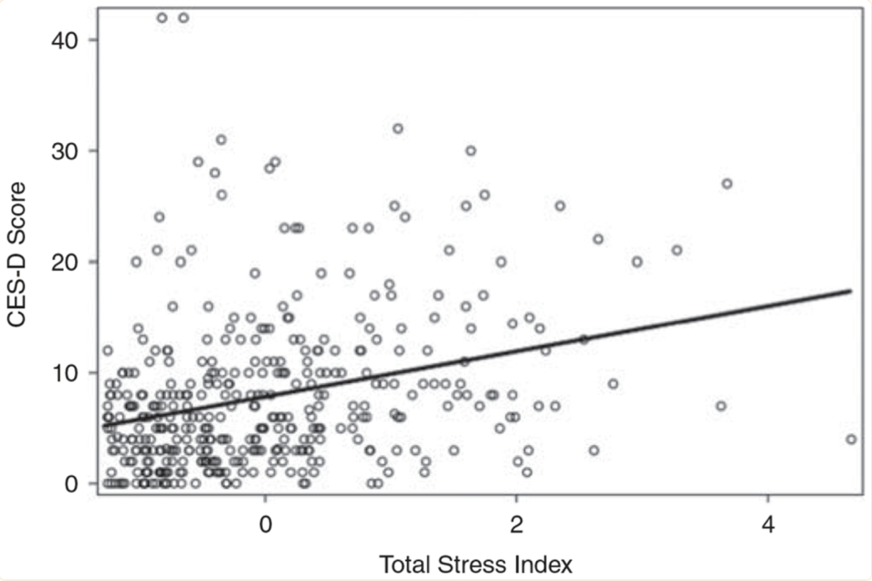

r = 0.72

**Notes: Adjusted for age, sex, race/ethnicity, alcohol intake and smoking status.**

In a series of questionnaires used to gather qualitative data, the miner’s reported threat of harm (intentional and unintentional), excessive work in hard conditions and a lack of support from supervisors as their three main stressors.

In your answer, refer to the above scenario by creating a well-constructed response, addressing the following:

* Outline what stress is according to Lazarus and Folkman (1984) and identify two types of stressors that the miner’s experience in their work. (4 marks)
* The university’s Internal Review Board is an example of an ethics committee. Describe the role of an ethics committee and outline twoethical guidelines that this committee would monitor during the study, stating how this would occur. (6 marks)
* Based on the data illustrated in Figure 1 on page 24, comment on the relationship between stress and depressive symptoms. (4 marks)
* Describe how psychological stress arises according to Lazarus and Folkman (1984) (2 marks)

|  |  |
| --- | --- |
| **Description** | **Marks** |
| **Outline what stress is according to Lazarus and Folkman (1984) and identify two types of stressors that the miner’s experience in their work.** | |
| * Stress is the consequence of the dynamic process where primary and secondary appraisals work to assess the significance of a situation (1) as well as evaluate ways to deal with it (1) | 1-2 |
| Any two of the following   * Environmental stress (work conditions) * Social Stressor (support from supervisor) * Psychology – meeting workload demand | 1-2 |
| **Sub-total** | **4** |
| **Describe the role of an ethics committee and outline two ethical guidelines that this committee would monitor during the study, stating how this would occur.** | |
| * An ethics committee evaluates proposed research to ensure it is following guidelines and monitors conduct of research | 1 |
| * Two ethical guidelines they would monitor are informed consent (1) and withdrawal rights (1) | 1-2 |
| * Informed consent is given by providing the miners information about the nature of the study | 1 |
| * It would provide information about the potential risks, their rights and the aim | 1 |
| * Withdrawal rights would be the miners have the right to exit the study at any point during the study | 1 |
| Accept other relevant responses |  |
| **Sub-total** | **6** |
| **Based on the data illustrated in Figure 1 on page 24, comment on the relationship between stress and depressive symptoms.** | |
| Based on the data, there is a moderately strong/strong relationship | 1 |
| Between stress and depression with miners who scored high on the Total Stress Index being more likely to score high on the CES-D (depression) | 1-2 |
| Whilst there is a positive correlation, we cannot say that stress causes depression, simply that there is a correlation between the two (correlation does not equal causation) | 1 |
| **Sub-total** | **4** |
| **Describe how psychological stress arises according to Lazarus and Folkman (1984)** | |
| Folkman described that stress arises from the continual need to assess their current situation (1) through primary and secondary appraisal (1) | 1-2 |
| **Sub-total** | **2** |
| **Total** | **16** |